Mike Schmitt

Play My Song

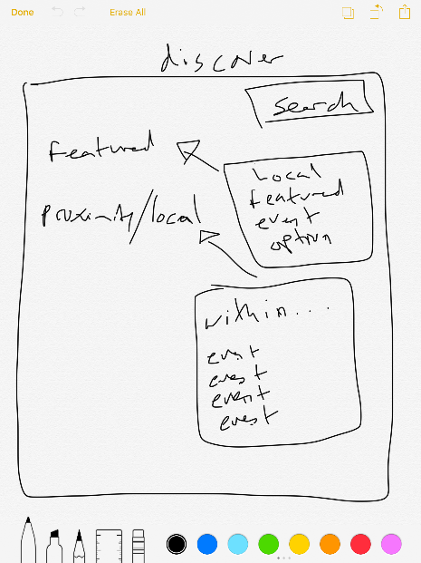

This is the discover tab that will be used to find events based on various parameters.

**Test 1:**

Input: The user will select the “Featured” button

Output: A list of events will appear based on the popularity of the event

Possible Errors:   
- Many events will be equal in popularity and the system will choose an event at random based on equal popularity  
- Events that the user does not want to see will be shown if it is popular  
- Proximity does not play a factor with this list

**Test 2:**

Input: The user will select the “Proximity/Local” button

Output: A list of events will be displayed in order of distance to the user

Possible Errors:  
- The user may not have location services turned on so the list will be out of order or blank

**Test 3:**

Input: The user will select the “search” field and it will highlight and text will be used to search

Output: Based on the text the event table will be filtered based on elements that resemble the name, location, DJ, and description

Possible Errors:   
- The user may put in invalid search parameters  
- There may not be any events that match the search parameter  
- code injection may occur